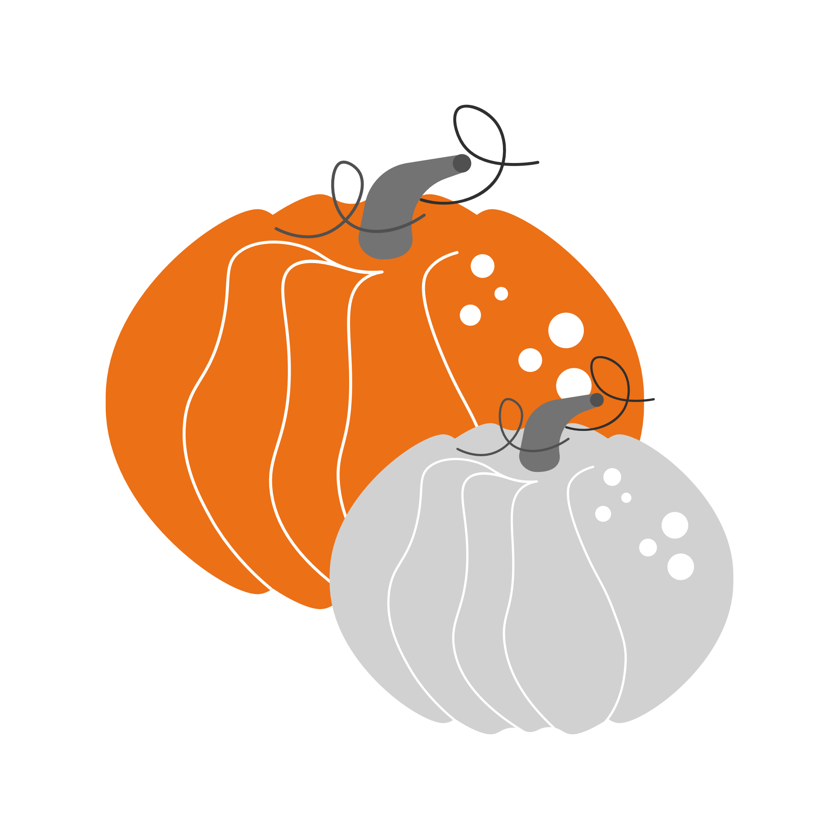
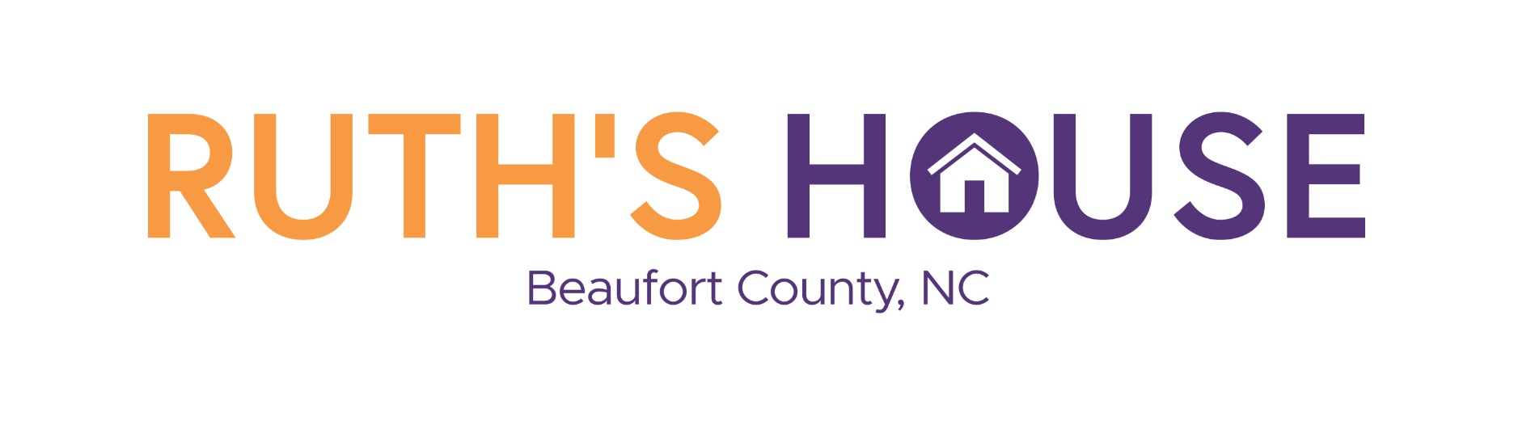
Most Requested Items
Fall 2022

home starter kits
Laundry Basket Filled with the Following Items:
☐ Broom and Dustpan
☐ Oven Mitts
☐ Silverware
☐ Plates and bowls
☐ Baking Sheet, Pot, Pan
☐ Cooking Utensils
☐ Plunger
☐ Toilet Bowl Cleaner
☐ Shower curtain liner and rings
☐ Screwdriver
☐ Flashlight and batteries
☐ Scissors
☐ Dust Cloths
☐ Sponges
☐First Aid Kit

Everyday needs
☐ Toilet Paper
☐ Paper Towels
☐ Aluminum Foil
☐ Laundry Detergent
☐ Bleach
☐ Disposable Gloves
☐ Disinfectant Spray
☐ Disinfectant Wipes
☐ Febreze Plug-In Refills
☐ Air Freshener
☐ Trash Bags
☐ Swiffer WetJet Pads
☐ Swiffer Refills
☐ Ziplock Bags (Gallon Size)

Items for Children
☐ Bug Spray
☐ Diapers
☐ Headphones
☐ Snacks
☐ Backpacks
☐ School Supplies

Items for Residents
☐ Earbuds
☐ Lotion
☐ Body Spray
☐ Daily Planners
☐ Gas Cards
☐ Gift Cards for Personal Clothing Items
☐ Hair Ties
The individuals and families who seek shelter at Ruth’s House often arrive with little more than the clothes they’re wearing.
​
Community donations bring the day-to-day items they need. We truly appreciate your generosity.

CALL 252-940-0007
TO ARRANGE
DONATION PICK-UP

